EXPERIMENT 1:

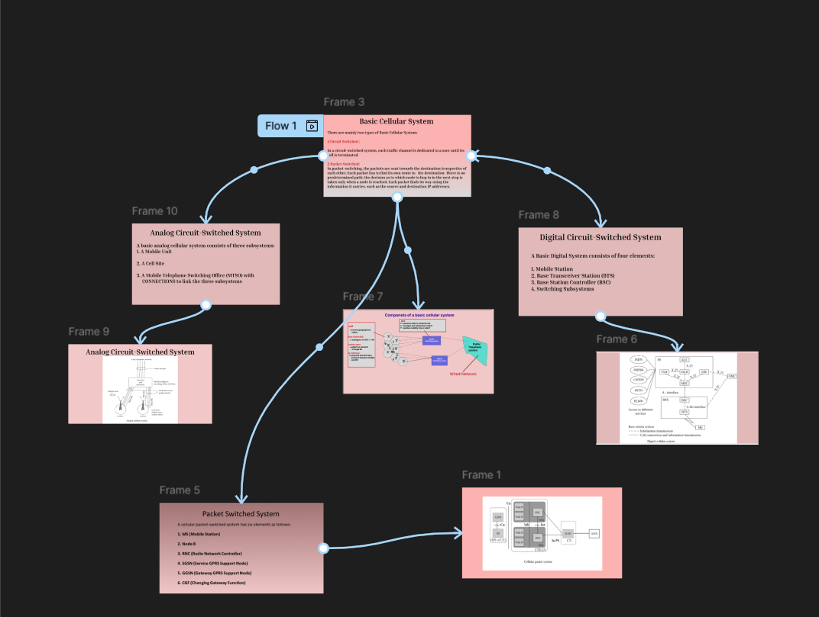

EXPERIMENT 2:

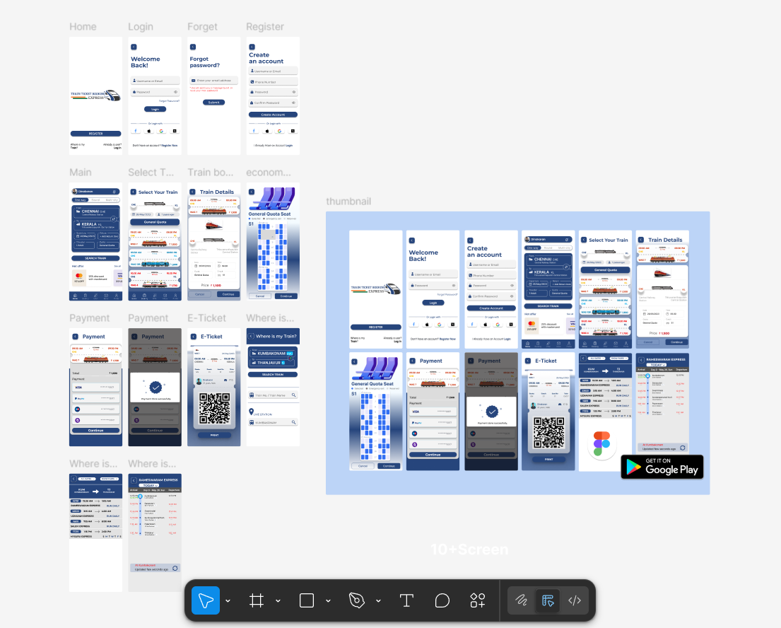

EXPERIMENT 4:

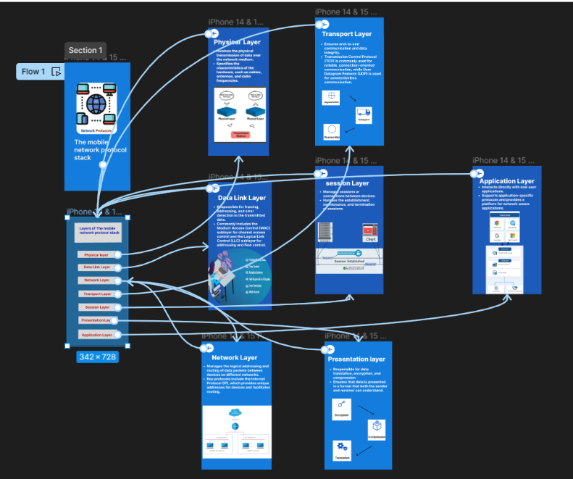

EXPERIMENT 5:

EXPERIMENT 6:

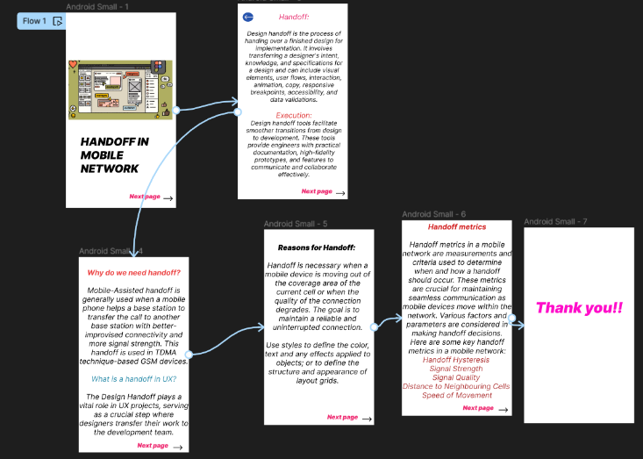

EXPERIMENT 7:

EXPERIMENT 8:

